**Beet Sprout 2**

Severity - Critical / Priority - Low

Example 1. When entering a website the cookie policy banner appears but the text slightly overflows the banner limits, hiding the last letters of the last word.

Example 2. When a user adds a specific product (only one product in 10000 sold by the store) to his wishlist, the wishlist is emptied and only that product is shown.

Severity - Minor / Priority - Highest

Example 1. The flag icon next to the language of the website is of a wrong country

Example 2. The logo color and font of a website is different when the user is on the homepage and when it selects a product category menu

**Mighty Beet 2**

The life cycle would be as followed:

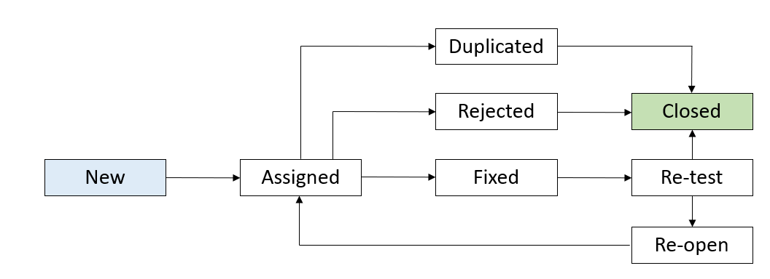

When the bug is detected, a bug report is opened and the bug is marked as “New”.

That bug is assigned to a developer (and is marked “Assigned”) that is going to evaluate the bug report.

If the developer doesn't consider that a bug it would mark the bug as “Rejected” and then “Closed”. If there is another bug report that addresses the same situation the bug would be marked as “Duplicated” and then it will be “Closed”. Otherwise, the developer fixes the bug and marks it as “Fixed”.

The bug will be retested and, if fixed, it would be marked as “Closed”. If the situation is not fixed the bug will be marked as “Re-open” and it will be assigned again to a developer to be fixed.